Explore R Simulation Techniques — 1-Page Summary Report
Monte-Carlo methods in base R applied to race-place distributions
Problem Statement
How can we quantify the uncertainty in finishing places for a group of friends in a race of unknown or variable size? Analytic formulas become cumbersome once we care about joint events (all three finish top-10) or non-uniform generative models. Simulation lets us answer these questions empirically, explore sensitivity to field size, and obtain approximate confidence intervals via the bootstrap—all with a few lines of base R.
Solution Strategy
1. Set a seed for reproducibility. 2. Write a single-trial function that draws places (sample / rnorm / …). 3. Repeat the trial many times with replicate() or sapply(), collecting results in a matrix. 4. Summarize with means, quantiles and empirical probabilities. 5. Visualize with histograms and boxplots. 6. Vary parameters (n_runners, success threshold) to study sensitivity. 7. Apply the bootstrap for non-parametric intervals. The same workflow extends to permutation tests and parametric bootstrap.
Solution (illustrative results)
Setting | E[place] | P(≤10) | P(all ≤10) | Notes
n=30, uniform | ~15.5 | ~0.33 | ~0.037 | Baseline
n=60, uniform | ~30.5 | ~0.17 | ~0.005 | Larger field
Bootstrap CI | — | — | — | 95% for mean place
Workflow flowchart and example Monte-Carlo plots (histograms + boxplot + top-10 probabilities):
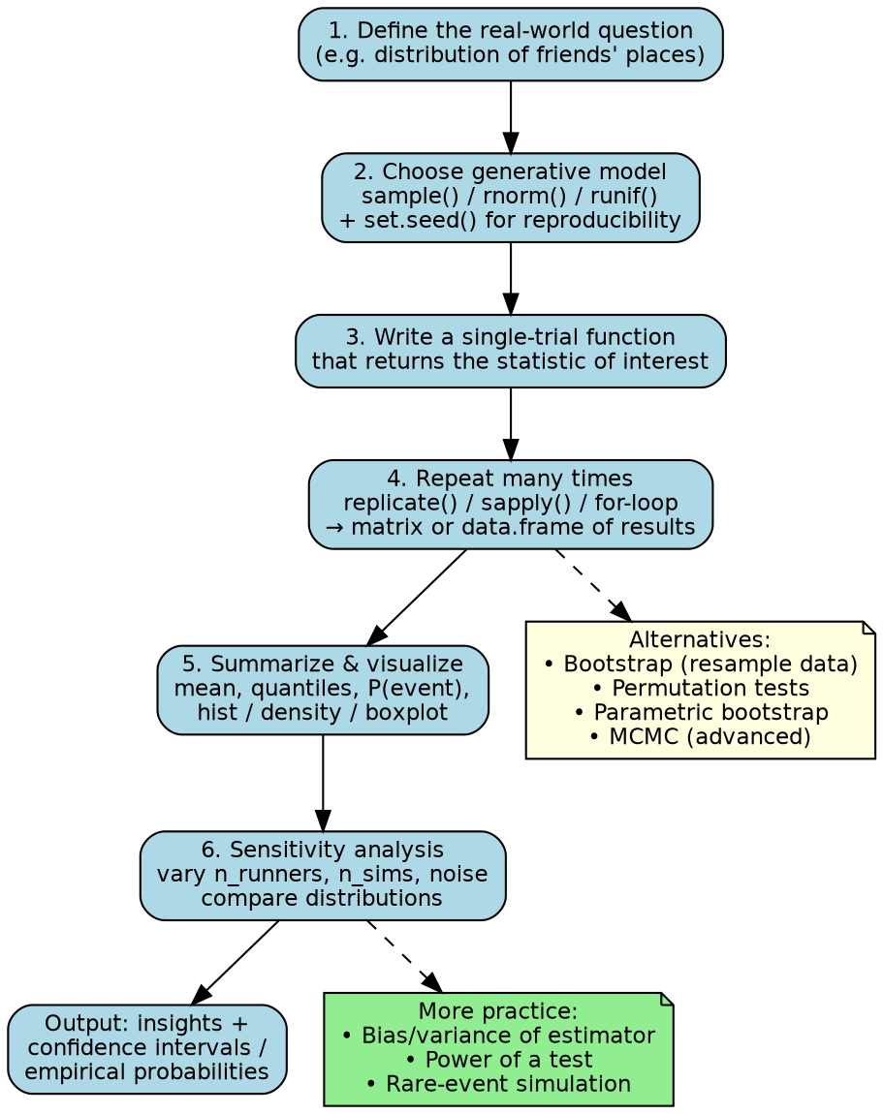
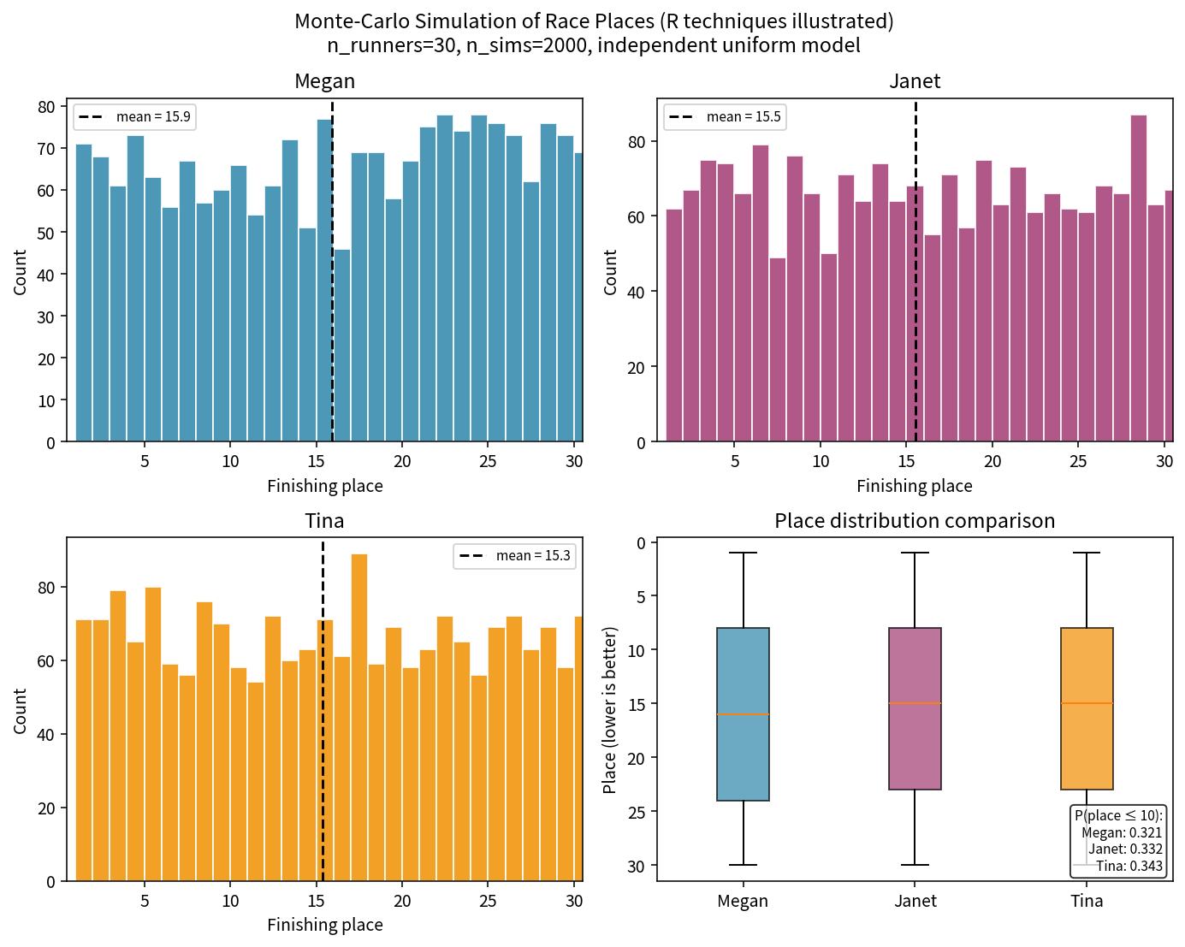
Key Takeaways
• set.seed + a single-trial function + replicate()/sapply() is the core Monte-Carlo pattern in base R.
• Empirical probabilities and quantiles are obtained simply by counting or applying summary functions to the result matrix.
• Sensitivity analysis (varying n_runners, thresholds, distributional assumptions) is almost free once the engine exists.
• The non-parametric bootstrap re-uses the same simulation ideas to produce approximate confidence intervals without analytic formulas.
• The identical workflow extends to power calculations, rare-event estimation, and simple randomization tests.
Files: Practice_Skeleton.ipynb • Solution.ipynb • flowchart.png • places_plots.png • Extended_Project.zip

